Question1:
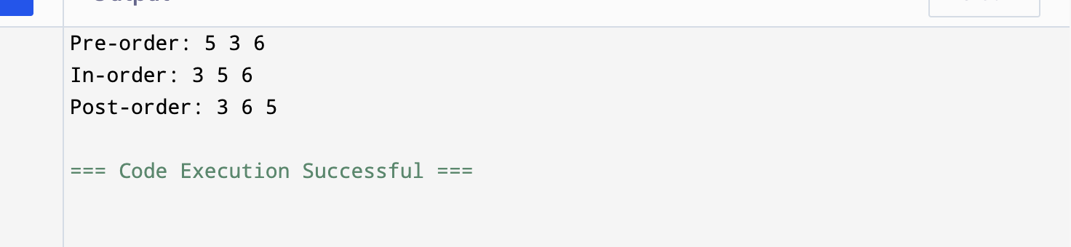

Quetsion2:
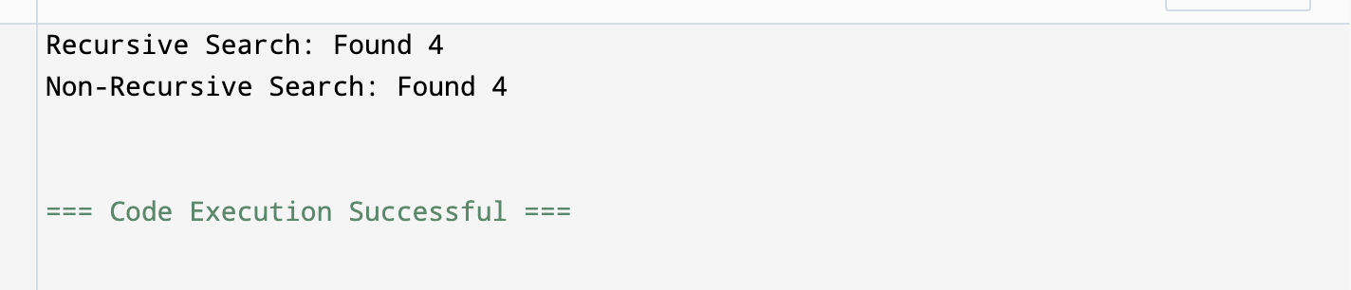

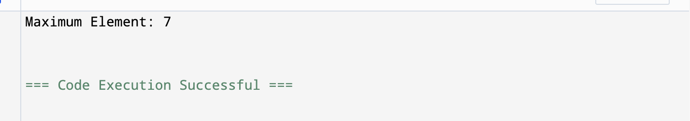
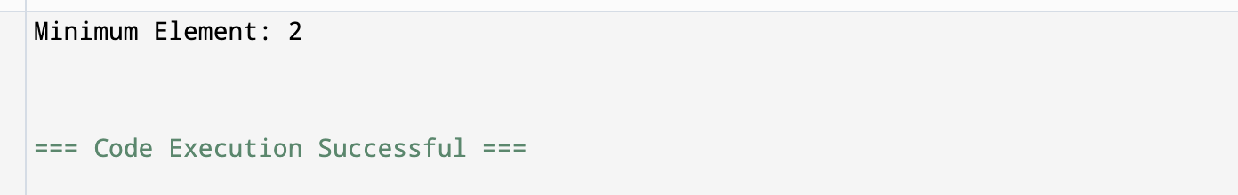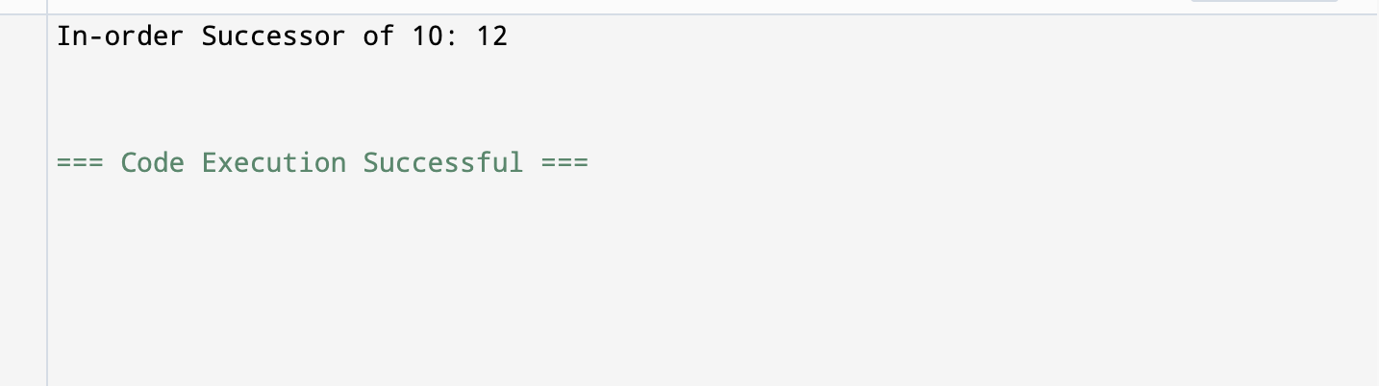

Question3:

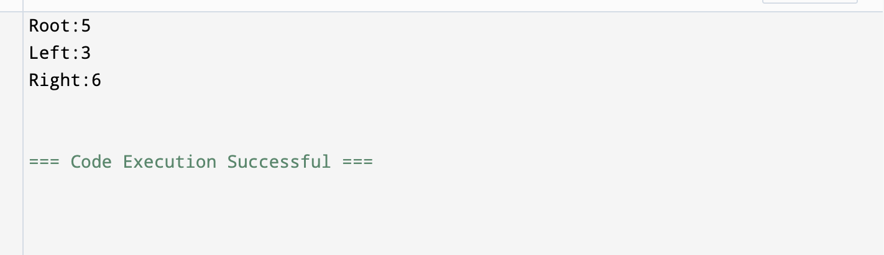

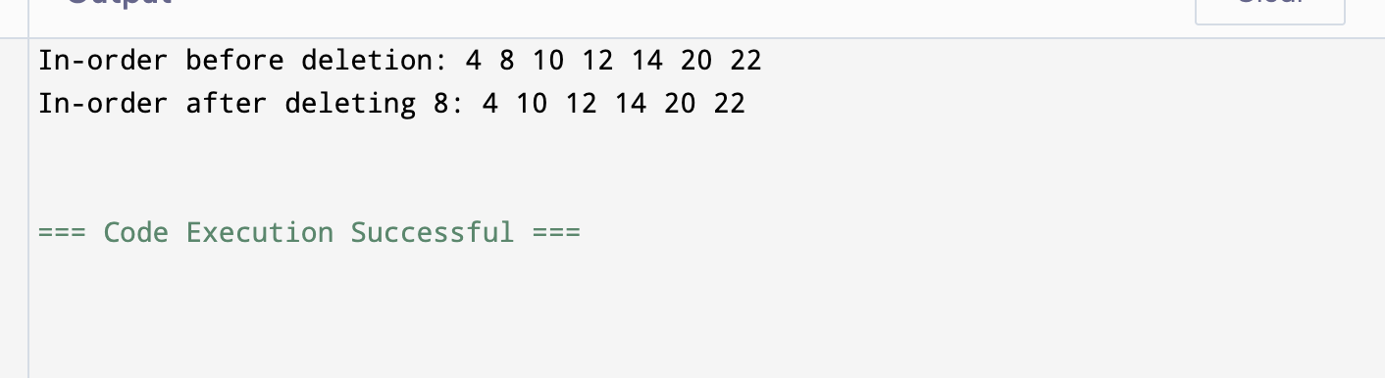

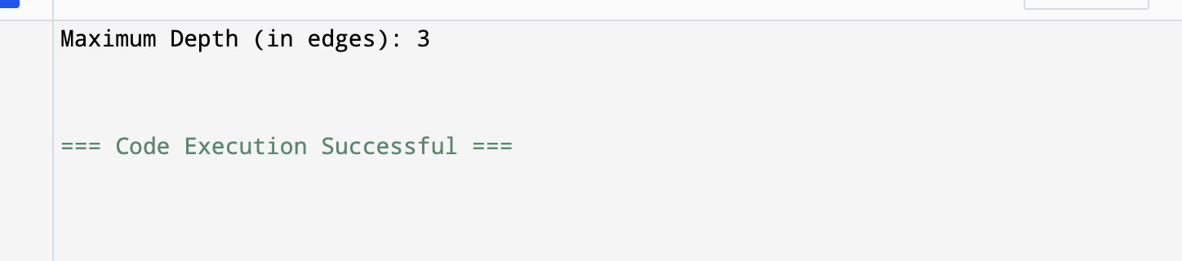

Question4:
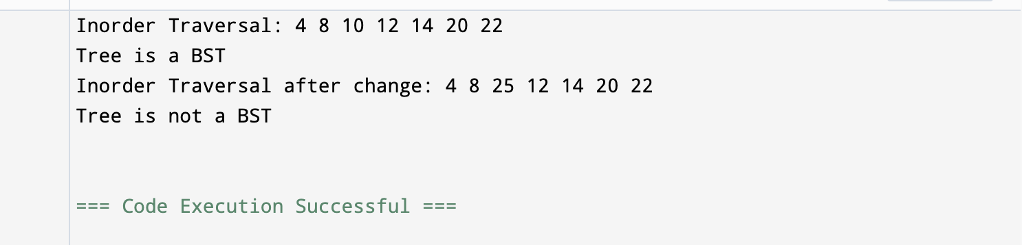

Question5:
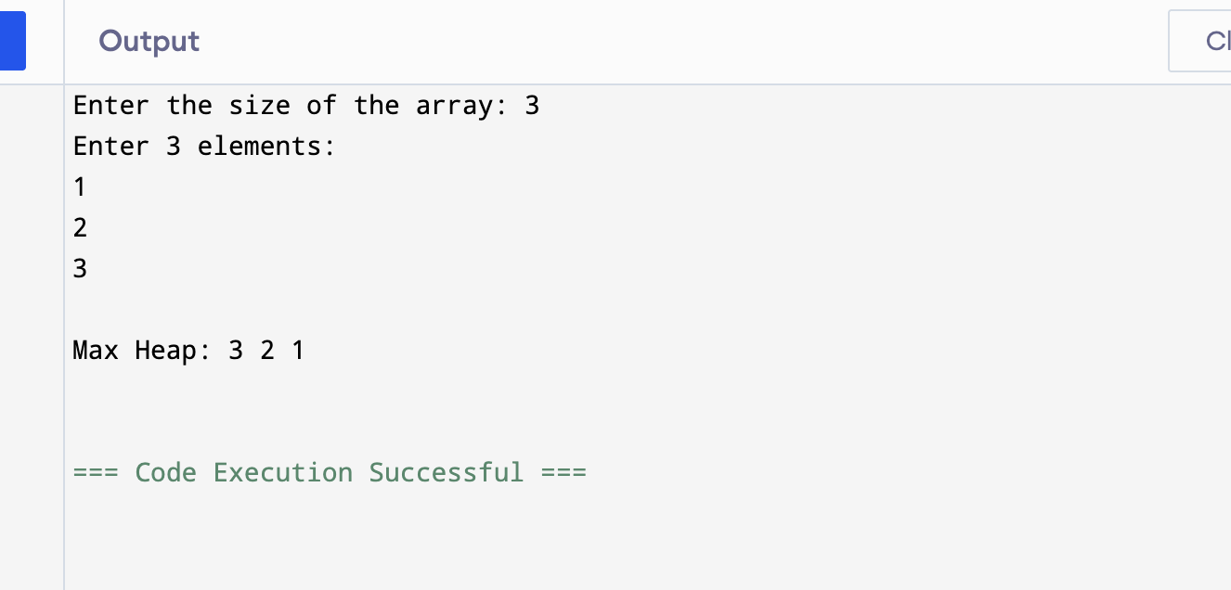

Question6:
